RWANDA POLYTECHNIC
RP – KARONGI COLLEGE
DEPARTMENT OF INFORMATION AND COMMUNICATION TECHNOLOGY
CAT PRACTICE — PROJECT BASED ASSESSMENT

PROJECT TITLE
MOTHERLAND PHARMACY
MANAGEMENT SYSTEM
A Console-Based Pharmacy Management System Developed in C with a MySQL Database
Case Study: Motherland Pharmacy
Submitted by: Thierry NDAYISHIMIYE
Institution: Rwanda Polytechnic (RP) – Karongi College
Development Tools: C Programming Language, MySQL, Dev-C++ IDE
Academic Year: 2025 – 2026
Date: August 2026

TABLE OF CONTENTS
I. Description of the Project
II. Problem Statement
III. Objectives
IV. System Requirements
V. Algorithm Design
VI. Database Design
VII. System Implementation
VIII. Conclusion and Recommendations

I. Description of the Project
The Motherland Pharmacy Management System is a console-based software application developed in the C programming language and backed by a MySQL relational database. The system was designed, coded and tested using the Dev-C++ Integrated Development Environment (IDE), which is the environment recommended for this assessment. Its purpose is to computerise the day-to-day operations of a community pharmacy, replacing manual, paper-based record keeping with a fast, centralised and reliable digital system.
The application connects to a MySQL database named pharmacy_db through the MySQL Connector/C library (mysql.h). All business logic is organised into clearly separated C source files, each responsible for one functional area of the system: database.c (database connection), login.c (authentication), medicine.c (inventory), sale.c (sales transactions), supplier.c and customer.c (partner records), users.c (staff accounts), report.c (business reports) and dashboard_report.c (system overview). A shared ui.c module centralises console formatting, prompts and input validation, giving the application a consistent, professional look and feel throughout every menu.
Overall, the system demonstrates the practical application of structured programming, relational database design and transactional data processing to solve a real business problem faced by Motherland Pharmacy.

II. Problem Statement
Many small and medium-sized pharmacies, including Motherland Pharmacy, continue to rely on manual, paper-based methods to record medicine stock, sales, customers and suppliers. This traditional approach is slow, prone to human error, and makes it extremely difficult to track stock levels accurately, identify medicines that are close to expiry, or generate reliable sales figures when they are needed.
Without a centralised system, the pharmacy risks selling expired medicine, running out of fast-moving stock without warning, losing track of supplier and customer information, and being unable to produce accurate daily or monthly performance reports for decision-making. These challenges directly affect both the safety of customers and the profitability of the business.
The Motherland Pharmacy Management System was developed to directly address these problems. It provides a single, database-driven application that automates inventory control, blocks the sale of expired medicine, records every transaction with full traceability, and instantly generates the operational reports pharmacy management needs to make informed decisions.

III. Objectives

1. General Objective
To design and implement a console-based Pharmacy Management System, using the C programming language and a MySQL database, that automates inventory control, sales processing, customer and supplier management, and business reporting for Motherland Pharmacy.

2. Specific Objectives
- To design a secure login and user-account module that restricts access to the system to authorised pharmacy staff only.
- To develop an inventory (medicine) management module that allows staff to add, view, search, update and delete medicine records, including tracking of stock quantity, price and expiry date.
- To implement a transactional sales module that records each sale, automatically updates medicine stock levels, and prevents the sale of expired medicine.
- To design a relational MySQL database that reliably stores and links data on medicines, suppliers, customers, users and sales.
- To generate real-time operational reports — such as daily sales, low stock, expired medicine and top-selling medicines — that support management decision-making.

IV. System Requirements

1. Functional Requirements of the System
Function | Description
Authentication | Staff log in with a username and password before accessing the system (login()).
User Management | Add, view, search, update and delete staff/user accounts (users.c).
Medicine (Inventory) Management | Add, view, search, update and delete medicine records, including price, quantity, category, supplier and expiry date (medicine.c).
Supplier Management | Add, view, search, update and delete supplier records (supplier.c).
Customer Management | Add, view, search, update and delete customer records (customer.c).
Sales Processing | Create a new sale with multiple items, view sale history, search sales, view a sale receipt, and delete a sale — all inside a database transaction (sale.c).
Reporting | Generate daily sales, all-time sales, low-stock, expiring-soon, expired-medicine, top-selling, sales-by-date, inventory-value and monthly reports, plus smart pharmacy advice (report.c).
System Overview / Dashboard | Display a summary snapshot of overall pharmacy performance (dashboard_report.c).

2. Non-Functional Requirements of the System
- Reliability: sales are processed inside a database transaction (START TRANSACTION / COMMIT / ROLLBACK), so stock and sales records always remain consistent even if an error occurs mid-transaction.
- Performance: the system uses direct, indexed SQL queries so that common operations (search, listing, reporting) return results quickly for typical pharmacy data volumes.
- Security: user access is protected by a login step, and input values passed into SQL statements are escaped to reduce the risk of malformed queries.
- Usability: a clear, menu-driven console interface with consistent headers, prompts and success/error messages (via ui.c) makes the system easy for pharmacy staff to learn and use.
- Portability: the system runs on Windows using the Dev-C++ IDE and the MySQL Connector/C library, and can be deployed on any machine with MySQL/MariaDB installed.
- Maintainability: the codebase is organised into independent modules (medicine, sale, supplier, customer, user, report), which makes it easy to maintain, debug and extend.

V. Algorithm Design

1. Pseudocode of the System
The pseudocode below describes the core algorithm of the system: processing a medicine sale (function sellMedicine() in sale.c). This is the most critical business process because it must validate stock and expiry, build a shopping cart, and update the database consistently.
BEGIN SellMedicine
cart <- empty list
grandTotal <- 0
DISPLAY list of customers
READ customerId (0 = walk-in customer)
IF customerId != 0 AND customerId not found THEN
DISPLAY error, RETURN
REPEAT
DISPLAY list of available medicines
READ medicineId
medicine <- SELECT name, sell_price, quantity, expiry_date
FROM medicines WHERE medicine_id = medicineId
IF medicine NOT FOUND THEN CONTINUE
IF medicine.expiry_date <= today THEN
DISPLAY 'medicine expired', CONTINUE
READ requestedQty
IF requestedQty <= 0 OR requestedQty > medicine.quantity THEN
DISPLAY error, CONTINUE
IF medicine already in cart THEN
increase its quantity and subtotal
ELSE
ADD medicine to cart with subtotal = requestedQty * sell_price
grandTotal <- grandTotal + subtotal
ASK 'add another item? (y/n)'
UNTIL answer = 'n'
IF cart is EMPTY THEN
DISPLAY 'sale cancelled', RETURN
CONFIRM sale with user
START TRANSACTION
INSERT INTO sales(customer_id, user_id, sale_date, grand_total)
saleId <- LAST_INSERT_ID()
FOR EACH item IN cart
INSERT INTO sale_items(sale_id, medicine_id, quantity, price, subtotal)
UPDATE medicines SET quantity = quantity - item.quantity
WHERE medicine_id = item.medicine_id
IF any database operation FAILED THEN
ROLLBACK, DISPLAY error
ELSE
COMMIT, DISPLAY 'Sale completed successfully', saleId
END SellMedicine

2. Flowchart Diagram of the System
The flowchart below illustrates the logical flow of the sale-processing algorithm described above, from customer selection through to the final commit of the transaction in the MySQL database.
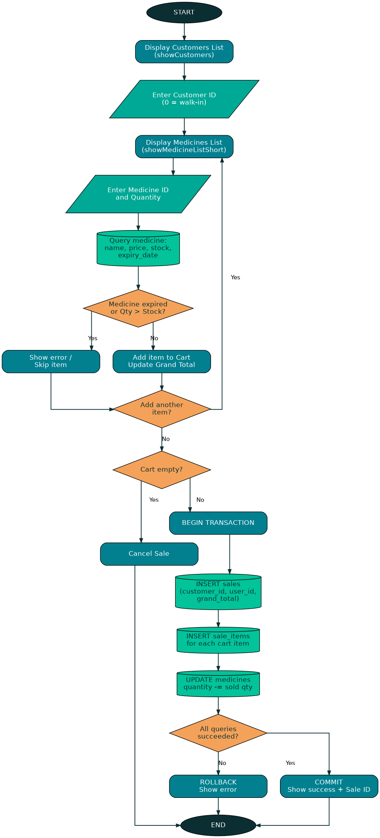
Figure 1: Flowchart of the Sell-Medicine (core sales transaction) process

VI. Database Design
The system uses a relational MySQL database named pharmacy_db, made up of six tables: users, medicines, suppliers, customers, sales and sale_items. The Entity Relationship Diagram (ERD) below shows every table, its attributes, primary keys, foreign keys and the relationships that link them together.
- One user (staff account) can create many sales.
- One customer can have many sales, and a sale may also belong to a walk-in customer (customer_id = 0).
- One sale can contain many sale_items (the individual medicine lines of that sale).
- One medicine can appear in many sale_items across many different sales.
- One supplier can supply many different medicines.

Entity Relationship Diagram (ERD)
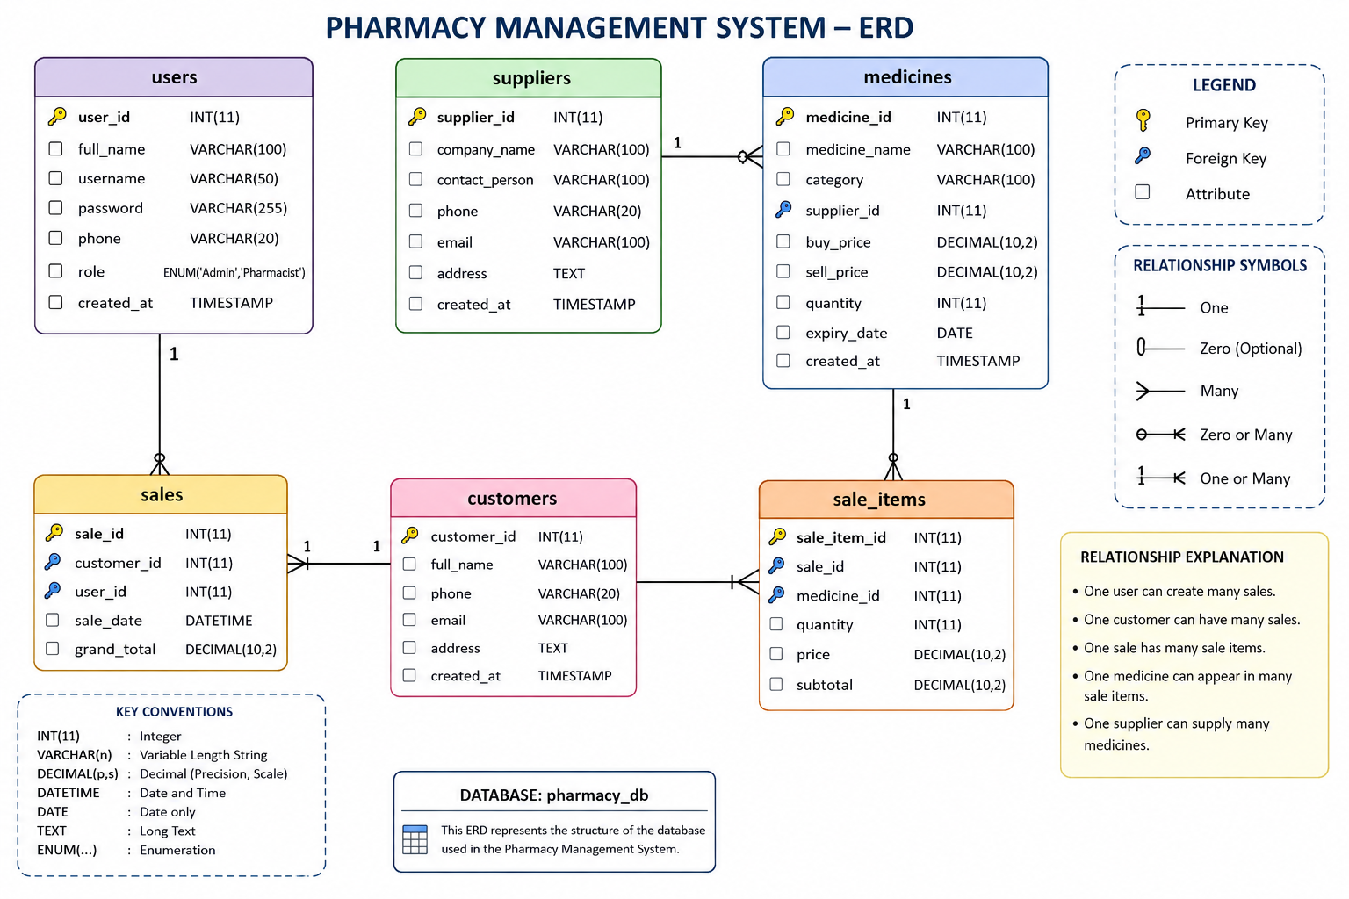
Figure 2: Entity Relationship Diagram (ERD) of the Motherland Pharmacy Management System database

VII. System Implementation
The system was implemented in C and compiled/run using the Dev-C++ IDE, connecting to a live MySQL database. The screenshots below demonstrate the working system, captured while running the compiled program, showing the main menu, login, dashboard, medicine management, sales processing and logout screens in sequence.

1. Login and Main Dashboard
The user first logs in with a valid username and password. On successful authentication, the system displays the main Dashboard menu, giving access to all modules: Manage Users, Manage Medicines, Manage Suppliers, Manage Customers, Sell Medicine, Reports, System Overview and Logout.
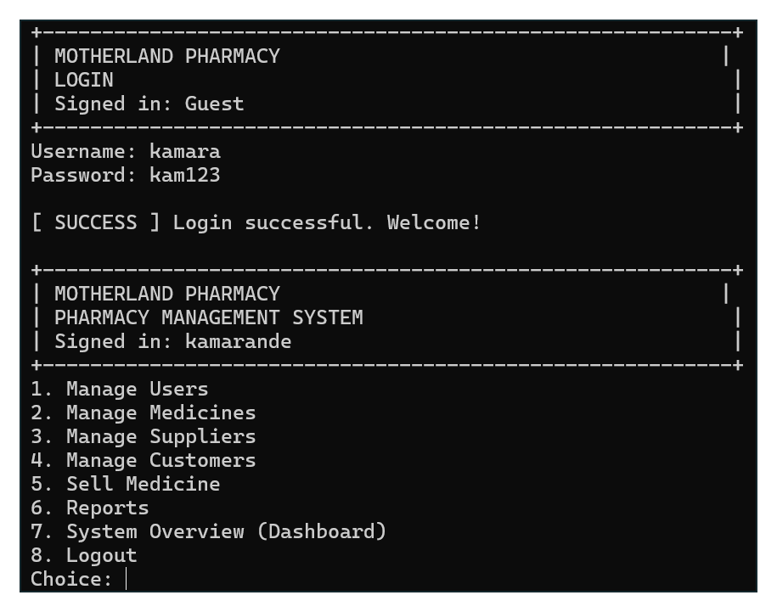
Figure 3: Login screen and the main Dashboard menu

2. Managing Medicines (Inventory)
From the Dashboard, selecting “Manage Medicines” opens the medicine management sub-menu, where staff can add a new medicine. The system displays the list of registered suppliers before prompting the user to enter the new medicine's details.
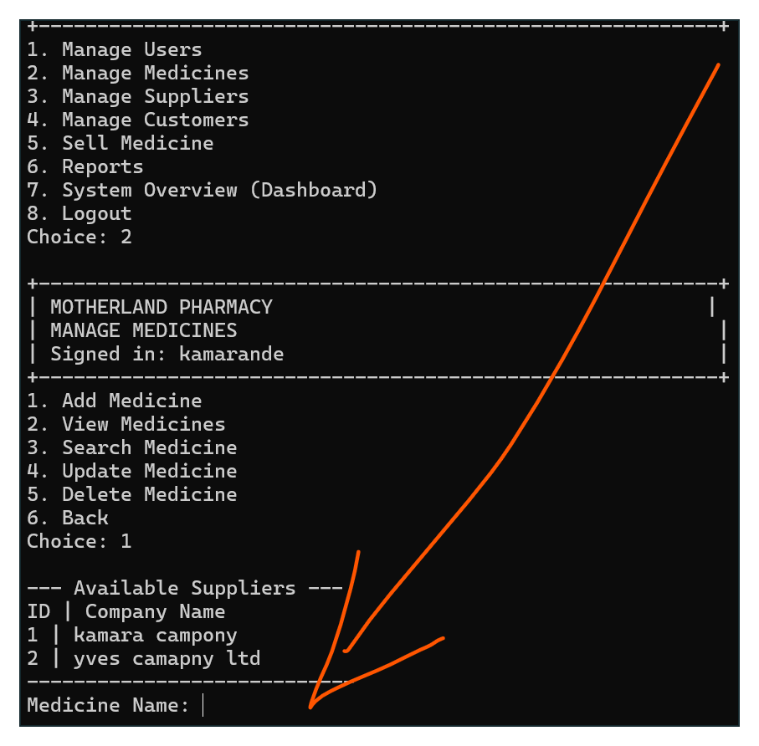
Figure 4: Manage Medicines menu and the Add Medicine screen

3. Selling Medicine
The “Sell Medicine” module lets staff record a new sale. The system first lists the available customers so the cashier can select an existing customer or process a walk-in sale, before moving on to select medicines and quantities for the cart.
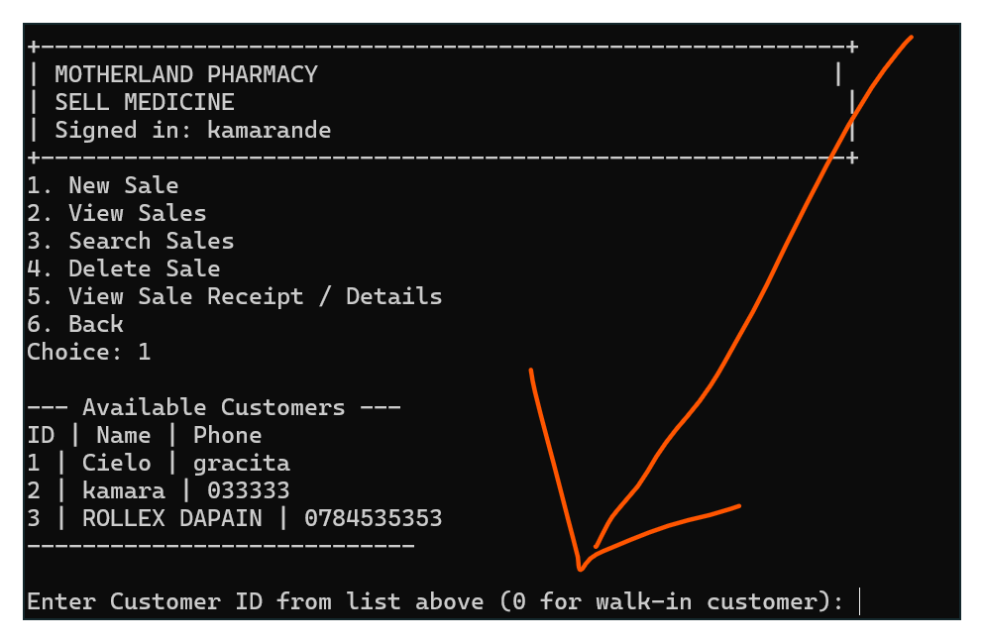
Figure 5: Sell Medicine menu and customer selection for a new sale

4. Logging Out
When finished, the user selects “Logout” from the Dashboard. The system confirms that the user has been logged out successfully and returns to the guest-level Main Menu.
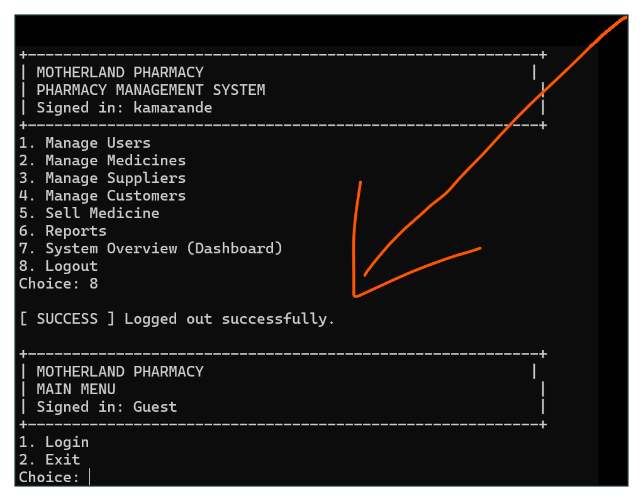
Figure 6: Successful logout, returning to the Main Menu

VIII. Conclusion and Recommendations

1. Conclusion
The Motherland Pharmacy Management System successfully demonstrates a complete, working solution to the operational problems faced by the pharmacy. Built in C with a MySQL backend and run through Dev-C++, the system provides secure staff login, full inventory management, transactional sales processing that automatically updates stock and blocks expired medicine, supplier and customer record keeping, and a wide range of operational reports and a dashboard overview. Testing of the compiled application confirmed that all major modules — authentication, medicine management, sales, and reporting — function correctly and update the pharmacy_db database consistently.
The project achieved its general and specific objectives, delivering a practical, database-driven system that replaces manual pharmacy record keeping with an accurate, efficient and reliable digital solution.

2. Recommendations
Based on the current implementation, the following improvements are recommended for future versions of the system:
- Strengthen security by storing passwords as hashed values (e.g., using bcrypt) instead of plain text, and by using prepared/parameterised SQL statements throughout the codebase instead of string-built queries.
- Add automated database backup and export features (e.g., CSV or PDF export of sales and stock reports) to protect pharmacy data and simplify auditing.
- Develop a graphical user interface (GUI), for example using a desktop framework or a web-based front end, to replace the console interface and improve ease of use for non-technical staff.
- Enforce explicit foreign-key constraints at the database level and add safeguards before deleting suppliers, customers or medicines that are already referenced by existing sales records.
- Introduce role-based access control so that “Admin” and “Pharmacist” accounts have different permissions within the system.

